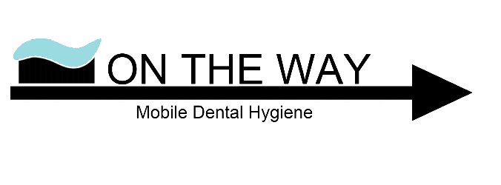

COVID-19 Pandemic Dental Treatment Consent Form
Patient name: _______________________________________
CMOH Order 05-2020 legally obligates any person who has the following core symptoms of cough, fever, shortness of breath, runny nose, or sore throat (that is not related to a pre-existing illness or health condition) to be in isolation (quarantine) for 10 days from the start of symptoms, or until symptoms resolve, whichever takes longer, or they receive a negative COVID Test. If they are exhibiting any of these symptoms, it is suggested they complete the COVID-19 Self-Assessment online tool to determine if they should be tested.
I understand the novel coronavirus causes the disease known as COVID-19. I understand the novel coronavirus virus has a long incubation period during which carriers of the virus may not show symptoms and still be contagious. ___________ (Initial)

I understand that due to the frequency of visits of other dental patients, the characteristics of the novel coronavirus, and the characteristics of dental procedures, that I have an elevated risk of contracting the novel coronavirus simply by being in a dental office. ___________ (Initial)

For Patients over 18, I confirm that I am not presenting any of the following core symptoms of COVID-19 as identified by Alberta Health Services:
• Fever > 38°C ___________ (Initial)
Recorded Temperature:_______________________
• Cough ___________ (Initial)
• Sore throat ___________ (Initial)
• Shortness of breath ___________ (Initial)
• Runny Nose ___________ (Initial)

For patients under 18, I confirm that they are not presenting any of the following core symptoms of COVID-19 as identified by Alberta Health Services:
• Fever > 38°C ___________ (Initial)
Recorded Temperature:_______________________
• Cough ___________ (Initial)
• Loss of sense of taste or smell ___________ (Initial)
• Shortness of breath ___________ (Initial)

I confirm I know that there are categories of people who are considered to be high risk. I understand the high risk category factors are being 65 years of age or older, heart disease, lung disease, kidney disease, diabetes or any auto-immune disorder. ___________ (Initial)
OR
I fall into the following high risk categories (_______________) and my dentist and I have discussed the risks, and I have agreed to proceed with treatment. ___________ (Initial)
I confirm that to my knowledge I am not currently positive for the novel coronavirus. ___________ (Initial)

I confirm I am not waiting for results of a laboratory test for the novel coronavirus. ___________ (Initial)
I confirm that understand that if I have to quarantine or have tested positive for COVID-19 I cannot enter a healthcare facility for 10 days or until my symptoms have resolved, whichever is longer. ___________ (Initial)

I verify that I have not returned to Alberta from any country outside of Canada whether by car, air, bus, boat or train in the past 14 days. ___________ (Initial)

I understand that any travel from any country outside of Canada, including travel by car, air, bus, boat or train, significantly increases my risk of contracting and transmitting the novel coronavirus. Alberta Health Services require self-isolation for 14 days from the date a person has returned to Canada. ___________ (Initial)

I confirm that I am not a participant in the International Border Pilot Testing Program. _____________ (Initial)
Or, I have participated in the International Border Testing Program and understand I am not permitted to enter a healthcare facility for 14 days after return from travel. _____________ (Initial)

I understand that Alberta Health Services has asked individuals to maintain physical distancing of at least 2 metres (6 feet) and it is not possible to maintain this distance and receive dental treatment. ___________ (Initial)

I verify that I have not been identified as a contact of someone who has tested positive for novel coronavirus or been asked to self-isolate by Alberta Health, the Communicable Disease Control or any other governmental health agency. __________ (Initial)
OR
I verify that I am a healthcare worker who has worn appropriate PPE. ___________ (Initial)

_________________________________________________________________________________
________________________________________________________________________
LIST of DENTAL TREATMENT

I verify the information I have provided on this form is truthful and accurate. I knowingly and willingly consent to have the above listed dental treatment completed during the COVID-19 pandemic.

______________________________
SIGNATURE OF PATIENT

Printed Name____________________________________ Date____________________

